[2012] Erdem Helvacıoğlu - Eleven Short Stories
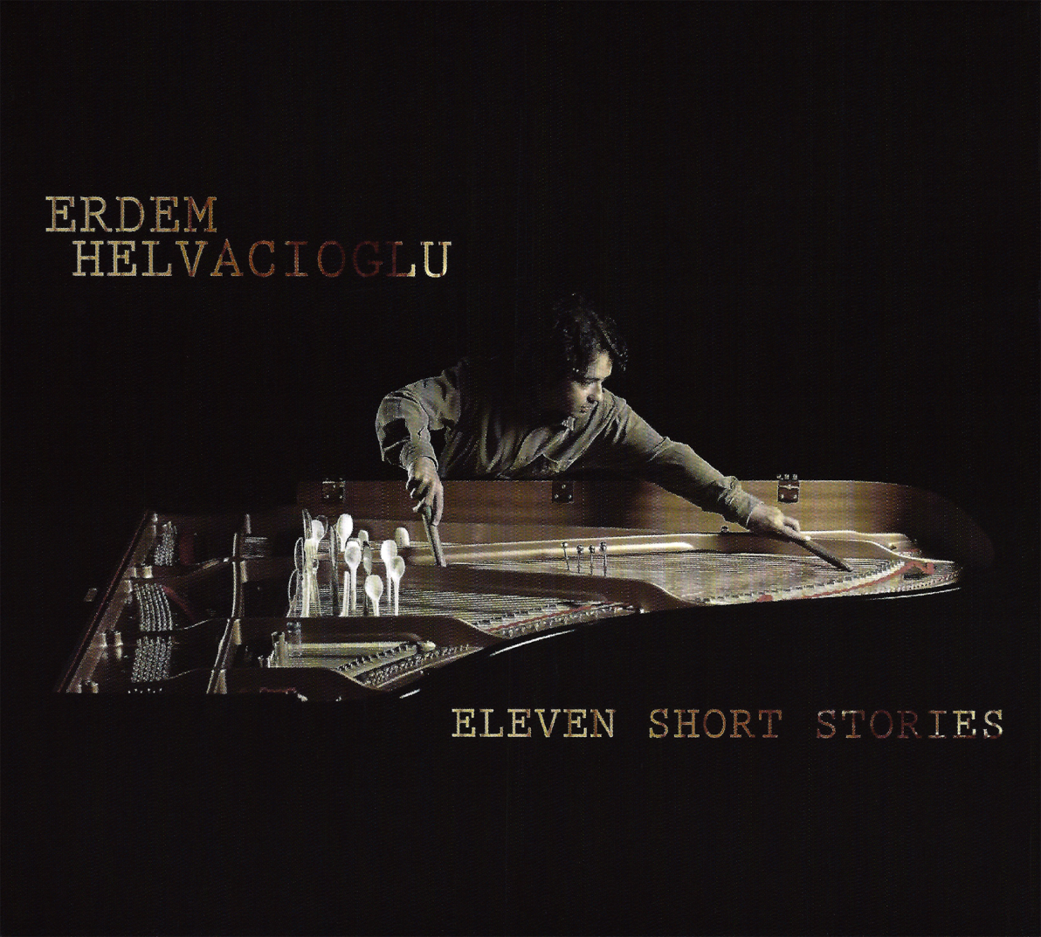

01 - The Billowing Curtain
02 - Bench at the Park
03 - Jittery Chase
04 - Shattered Snow Globe
05 - Six Clocks in the Dim Room
06 - Mist on the Windowpane
07 - Blood Drops by the Pool
08 - Have Not Been Here in Forty Years
09 - Trapped in the Labyrinth
10 - Will I Ever See You Again
11 - Shrine in Ruins

